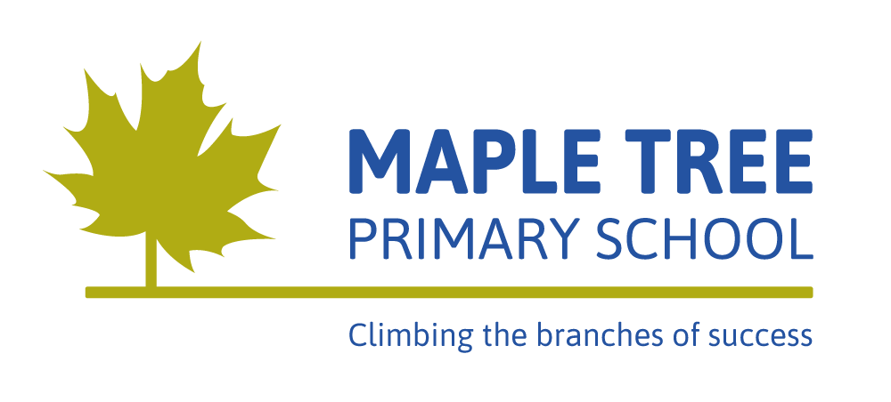
Long Term Curriculum Upper Key Stage 2 Year 6
 | Autumn 1 | Autumn 2 | Spring 1 | Spring 2 | Summer 1 | Summer 2
Topic | Lest We Forget!  (History) |  | The Game of Survival  (Science) |  | Location! Location! Location!  (Geography)
Key Texts | Poems from the Second World War selected by Gaby Morgan  Anne Frank’s diary  Friend or Foe by Michael Morpurgo  Number the Stars by Lois Lowry  WW2 non-fiction texts including The Cabinet War Rooms. |  | Various non-fiction texts about evolution and inheritance  The Zebra’s Stripes and other African animal tales by Dianne Stewart, Poetry Anthology  The First Drawing by Mordicai Gerstein, Stone Age Boy by Satoshi Kitamura, The Secrets of Stonehenge by Mick Manning |  | Various non-fiction texts on world countries, travel books – including Japan (Olympics 2020)  This is how we do it: A day in the life of seven children from around the world by Matt Lamothe  Folktales of Mexico: Horse hooves and chicken feet: traditional Mexican stories by Neil Phillip
Cross curricular English | Historical stories, diary entries, Remembrance poetry, recounts, speeches (Churchill), persuasive texts. |  | Folk tales, villainous characters (poetry), information texts |  | Persuasive texts, Blogs and reports, Stories from different cultures, instructions and explanations (sports for Olympics)
Cross curricular Maths | Coding and algorithms |  | Cladograms |  | Data, coordinates and scales
Science | Light | Electricity | Evolution and Inheritance | Living things and their habitats – classification | Animals, including humans – circulatory system, lifestyles, reproduction.
Science Practical Investigation – at least one per half term | Investigate the brightness of bulbs (search lights) | Create a circuit board quiz – investigating electricity  Create a dimmer switch. | Family tree investigation | Classification in our backyard | Nutrient detectives | Investigate different exercises and the effects on their bodies
Design and Technology | VE Day street party – plan and food prep |  | Evaluate bird boxes, design and make |  | Build a ski lift – Alps link
Art and Design | Class memorial art installation to remember the Holocaust and the Jewish people who were killed. |  | Art week – Islamic art (History) |  | Ansel Adams photographs of The Grand Canyon  Mexican art and culture
Geography | European geography, changes |  | Creatures that survive in a range of environments and biomes, understand key aspects of physical geography, including: climate zones. |  | Compare people and place in a Local Area, Japan, The Grand Canyon, Mexico, Alps and Amazon Basin.
History | Jewish people during World War 2, including prejudice, oppression and the concentration camps. Study the life of the positive and inspirational Anne Frank. Develop an understanding of who Churchill was and his significance as a leader. |  | Meet Darwin, Anning and Wallace - the evolutionary dream team |  | Mexican fiestas, heritage
Computing | Film making | Kodu programming | Spreadsheets |  | Scratch: Animated stories | Online Safety
Music  (Inspiring Music Online) | I’ll be there – listen and appraise | Classroom Jazz 2 - Bacharach Anorak and Meet The Blues. | A New Year Carol - research Benjamin Britten’s life and to listen to many of his other works | Happy - dimensions of music (pulse, rhythm, pitch etc), singing and playing instruments | You’ve Got a Friend – composing, improvising and performing | Reflect, Rewind and Replay – consolidating music skills.
Physical Education (P.E) | Outdoor Ed  Football | Tag Rugby  Badminton | Gymnastics | Dodgeball  Dance | Tri golf  Basketball | Athletics  Rounders & Cricket
Personal, Social, Health, Citizenship Education  (P.S.H.C.E) | Health and wellbeing | Relationships |  | RSE – health and wellbeing | Living in the wider world
Languages (French) | Let’s visit French town |  | Let’s go shopping |  | This is France | All day
Religious Education  (R.E) | What does it mean if Christians believe God is holy and loving? | How does faith enable resilience? Christianity, Muslims, Jews and others | How is faith expressed in Islam? | What will make our community a more respectful place? Religious and non-religious ideas. | Justice and poverty: Why does faith make a difference? | Creation and Science: conflicting or complimentary? Christians and non-religious people.
Visits and Events | Trip to Bletchley park – Maths and Coding link |  | Trip to Natural History Museum, London |  | Year 6 plan their end of Primary trip

